Use Case:

This project is used to record users’ transactions history listed with date, amount and the item category.

The user interface looks like this:

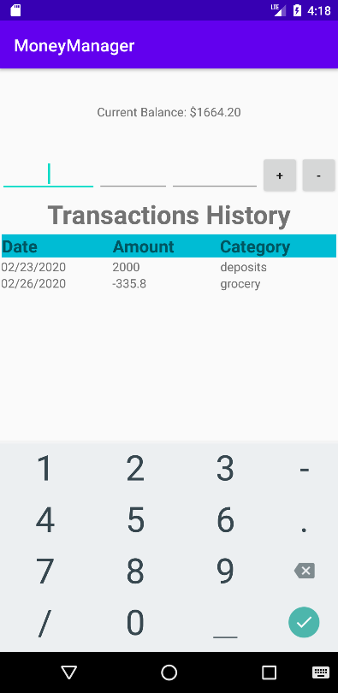

User can enter date, amount of money and category in order

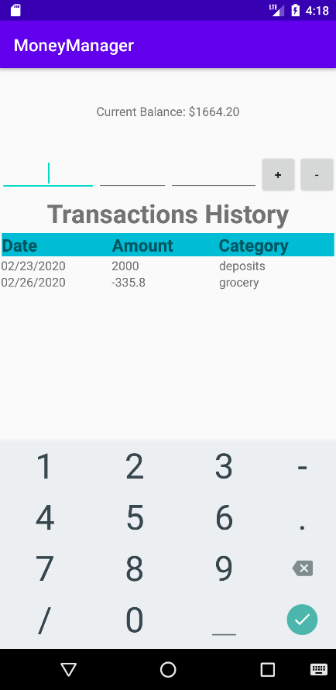

After entering all those values, user can either hit “+” or “-” button.

“+” button function as adding money into account, and

“-” button function as subtracting money from account.

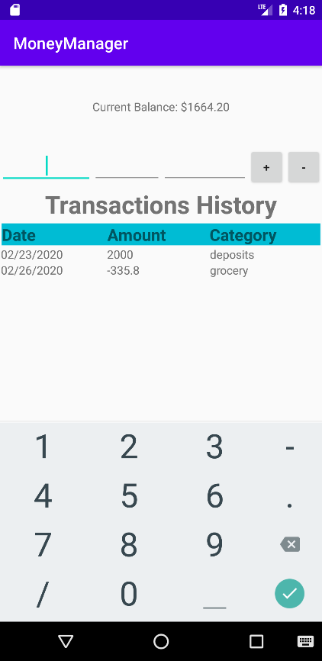

After hitting buttons, the transaction history will be recorded as a table at the bottom：

